**CHICAGO CRIME – 2001 TO PRESENT**

DIVYA PAKHALE

CALIFORNIA STATE UNIVERSITY LOS ANGELES

SUBMITTED TO: DR. SHILPA BALAN

**OBJECTIVE OF STUDY:**

Crime is the activity which has become more violent over past several years. Crime has always been the greatest issues in any city, region or country. Chicago is one of the most dangerous cities than other cities in US. Crime in Chicago has been tracked by Chicago Police Department’s Bureau. Crime is increasing over years and hence it has become mandatory to find out the possible reasons to secure and save lives globally. The city’s overall crime rate, especially the violent crime rate is substantially higher than the US average. By doing analysis on Chicago Crime, we were able to bring out how crime is increasing and decreasing over the years in the city of Chicago. Also, when we analyzed the data, we were able to see the several types of crime, government may be able to take necessary steps for the safety of their people.

**ABOUT CHICAGO CRIME DATASET:**

This Dataset has a crime data of city of Chicago from 2001 to present. It is extracted from the Chicago Police Department’s CLEAR (Citizen Law Enforcement Analysis and Reporting) system. It includes unique case number, year in which crimes occurred, indicates whether arrest was made, and different districts in which crimes occurred.

1. **DATA SETLINK:**

https://data.cityofchicago.org/

[**https://data.cityofchicago.org/Public-Safety/Crimes-2001-to-present/ijzp-q8t2/data**](https://data.cityofchicago.org/Public-Safety/Crimes-2001-to-present/ijzp-q8t2/data)

1. **DATA CLEANING**
2. Sorting

ID’s are not in sequencial order.

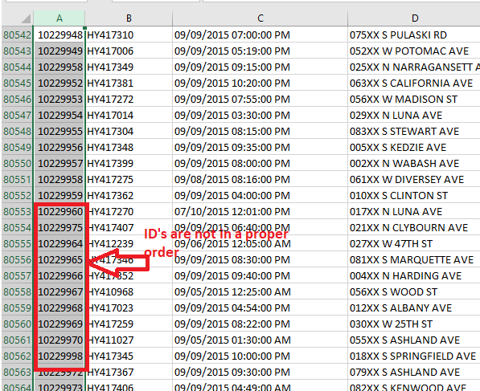After arranging in sequential order.

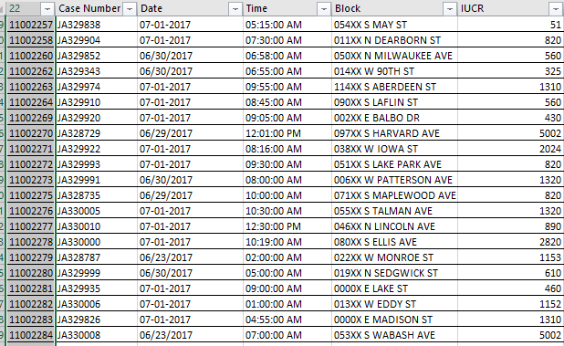

1. Illegal Data Format

Value of the month exceeds outside of domain range.

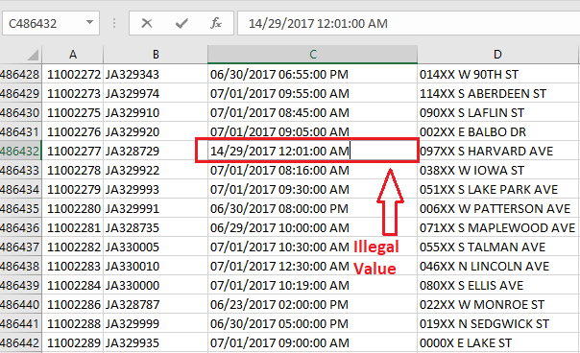

1. Embeded Values

Location column has two columns merged into it i.e Latitude and Longitude

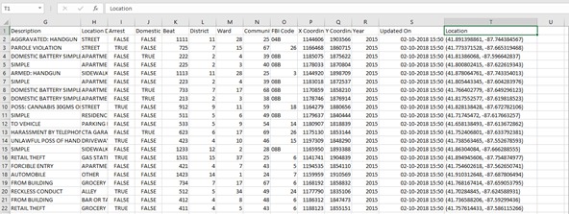

Location column is now split into Longitude and Latitude

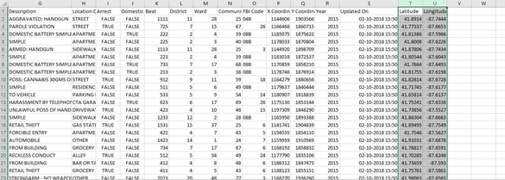

1. Violated attribute dependencies

IUCR code is directly dependent on Primary Description.

For IUCR code – 460 Primary Type should be Battery

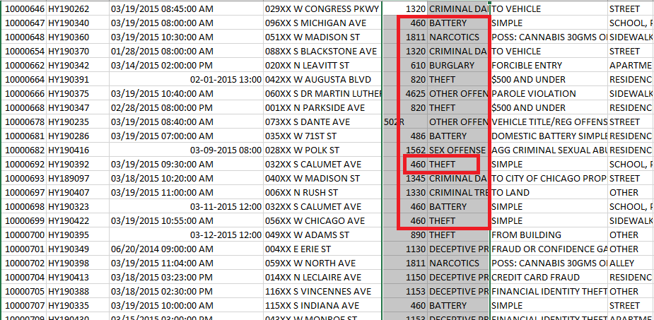

After Cleaning

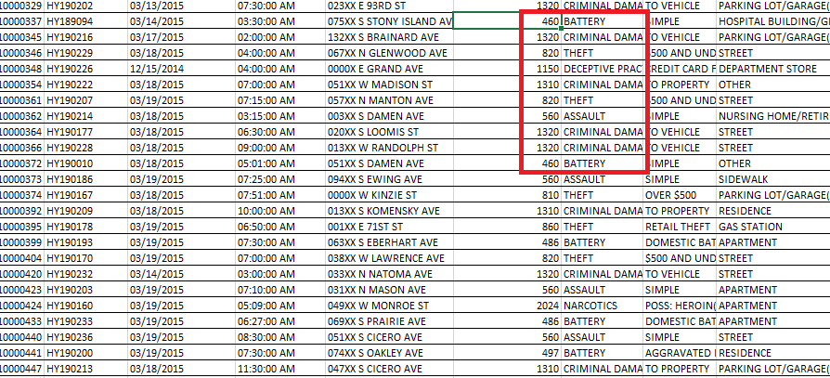

1. Duplicate Records

In Primary type column, non-criminal value type is duplicate

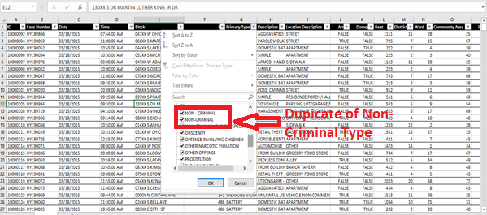

After removing duplicate values

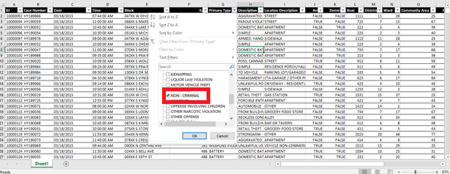

1. **DATA VISUALIZATION**
2. CRIME TREND IN CHICAGO

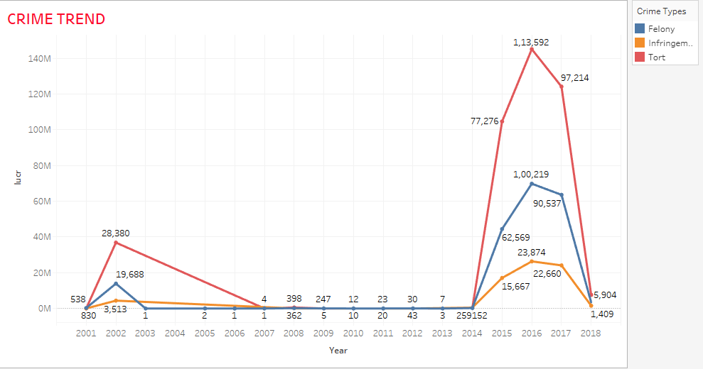

[Application Used: Groups]

In this visualization, all Primary type of Crimes are grouped into 3 main types i.e Felony, Infringement and Tort. A field name Crime Type was created with the help of Group function to combine all Primary types into 3 categories. This continuous line graph depicts 3 types of crimes in different year and its number of records with its IUCR code. This explains about in which year what type of crimes occurred and the number of records for each crime.

1. MAXIMUM NUMBER OF CRIMES IN DIFFERENT LOCATIONS

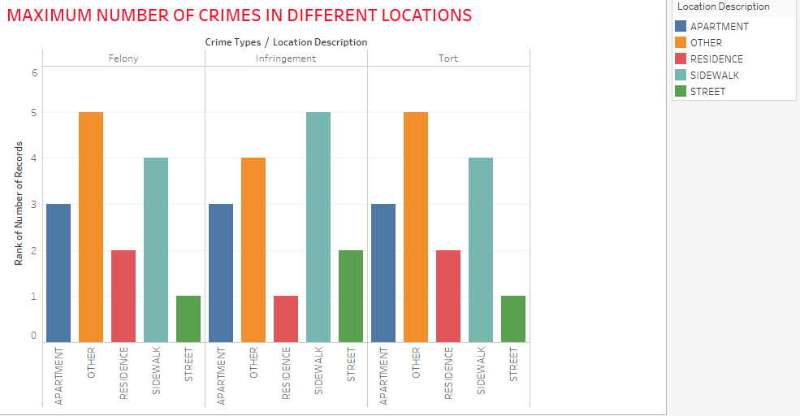

[Application Used: Rank]

This vertical bar graph describes about the maximum number of crimes occurred in top 5 locations. Newly created Crime type field is used to show the crime type. Crime types are grouped into 3 main categories as Felony, Tort, Infringement. Filter function is used for top 5 location description. With the help of Rank function, we can count the number of records along with the location description.

1. SAFEST LOCATIONS IN CHICAGO

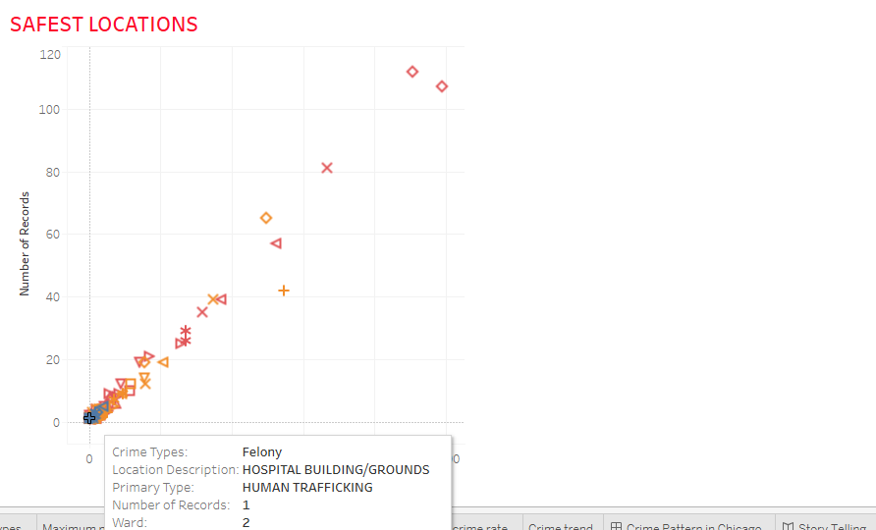

[Application Used: Scatter Plot, Filter]

The above visualization describes the Safest Locations in Chicago with the help of scatter plot. Primary type and Crime Types are filtered using bottom approach. Places like hospitals, Police facility, Apartments are the safest to stay. It helps us to understand in which ward the incident took place and what are the number of records for each crime. Based on this, people can identify the chances of crimes occurred.

1. MOST DANGEROUS TYPE OF CRIME

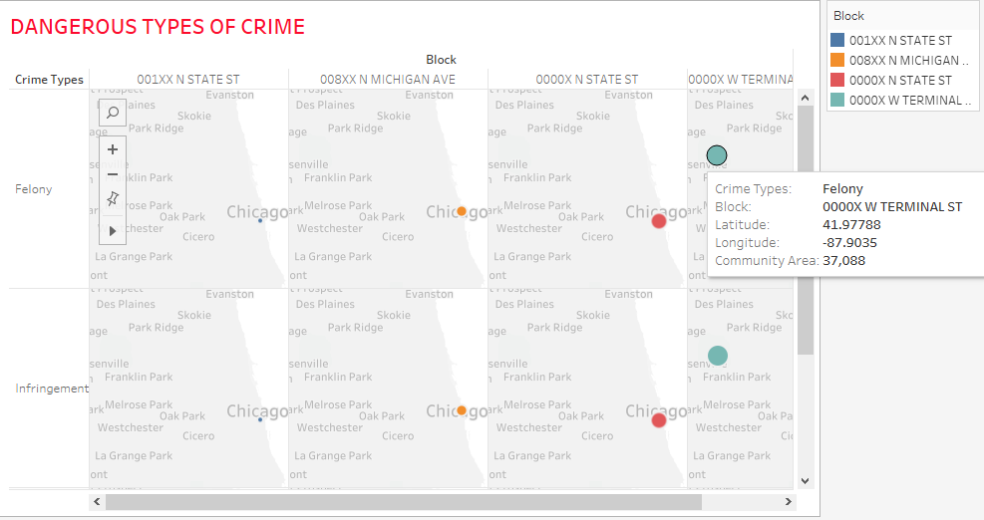

[Application Used: Geographic Map]

The geographic map shows the top four crime infested blocks on the basis of maximum number of crimes occurred. We can see from the map that Terminal Street block has the most dangerous types of crimes compared to other crimes. By this analysis, it’s very clear that which area has loopholes in safety measures. These are the areas which needs special attention. These records can also be helpful for common people or visitors, so that they can stay alert while commuting. People can also think wisely before investing in properties in such areas.

1. MOST FREQUENT TYPES OF CRIMES IN DIFFERENT BLOCKS

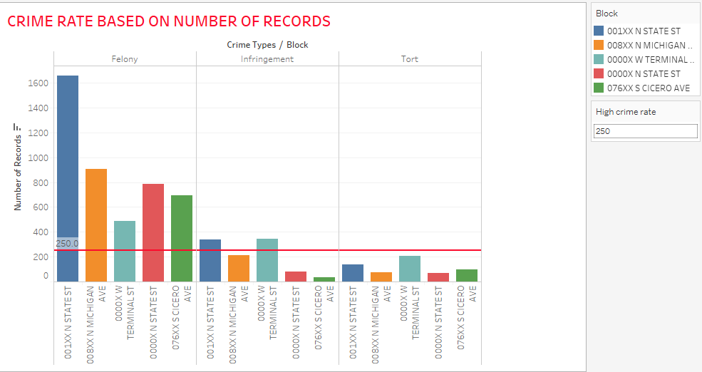

[Application Used: Reference Line]

This analysis gives us a highlight for top 5 blocks along with Crime Types and Number of Records. Reference line gives the average number of any crime recorded in particular block. In this analysis, the reference line is set on as an average derived from number of records. We can see that average number of record is 250. Hence the types of crime in top 5 blocks is getting reduced as compared to the average rate. This is a positive indication that the value is gradually decreasing. Hopefully in future years these crimes get almost eradicated from the city.

1. ARREST vs NON-ARREST

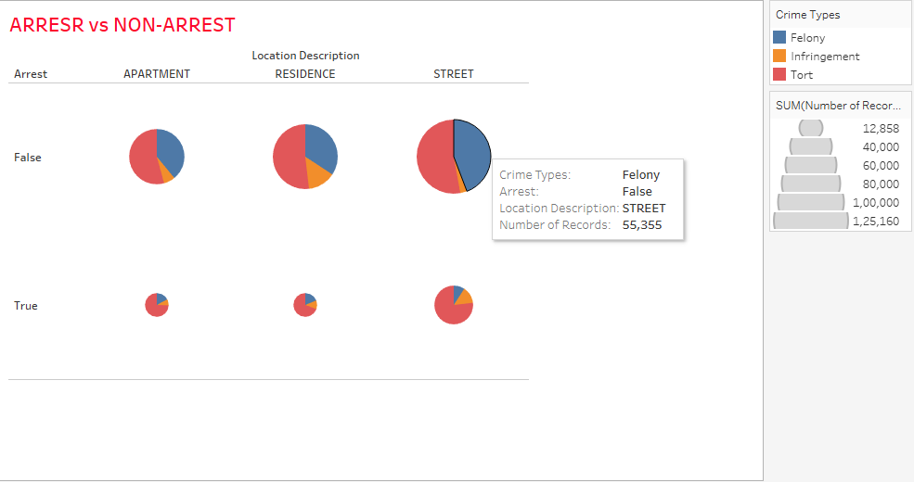

[Application Used: Pie Chart, Filter]

This visualization shows about the number of criminals arrested versus not arrested in the top 3 locations. Filter function is used to sort the location description. It also helps us to understand what the different types of crime in that particular location are and whether the criminals are arrested or not in that location. From this, people will be alerted whether the criminals for the particular type of crime are arrested or not.

1. **DASHBOARD**

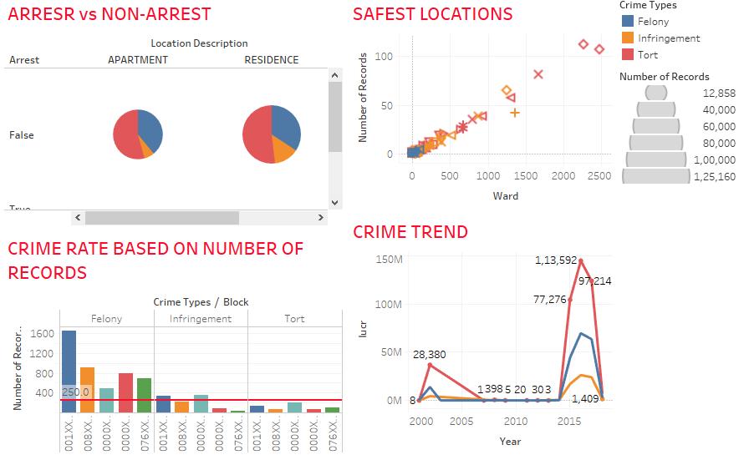

1. **STORY TELLING**

In general, crime is an act punishable by law, usually considered an evil act. Crimes refer to many types of misconduct forbidden by law. Crimes includes things like murder, stealing, dealing of illegal drugs, drunk and drive etc. Crimes are frequently classified according to their seriousness as felonies, Infringement and tort. Generally, felonies are more serious than tort.

Chicago is one of the most dangerous cities than other cities in US. Crime in Chicago has been tracked by Chicago Police Department’s Bureau. Crime is increasing over years and hence it has become mandatory to find out the possible reasons to secure and save lives globally. The city’s overall crime rate, especially the violent crime rate is substantially higher than the US average. It is said that north region of the city is quiet and safe, whereas the south region especially the area nearby to the university is not safe and can be very dangerous. Chicago was responsible for nearly half of 2016’s increase in homicides in the US, though national crime rates stayed near historic lows.

Crime and killings in Chicago have reached such epidemic proportions that some kind of Federal help is needed. What if murder could be predicted? What if police could intervene with the future victim or future killer? To answer all these questions, in Chicago an experimental computer program is trying to prevent crime by predicting it. In 2016 more than 760 people were killed and there was around 58% increase in assault and gambling rate. Hence it is important to look into the crimes happened over the years, what are the number of records and what measures should be taken to reduce the crime rate. Here the analysis done in this project gives the insight on five main research questions.

1. Crime Trend in 2000 till present in Chicago.

The information present in this report depicts about the types of crime occurred from 2000 until present year i.e 2018. There are several different types of crimes which are categorized into 3 main types of crimes i.e 1) Felony – it means an offence or a murder. Hence, arson, assault, burglary are included in this type. 2) Tort or misdemeanors – which means offense against law and it includes criminal damage, intimidation, etc. 3) Infringement – violation of a law and includes criminal trespass, deceptive practice types of crime. This story determines the 3 types of crimes in different years. This helps us to understand which crime is the most popular. According to the analysis, we can determine the top most crime based on the IUCR code. In the year 2016, the highest record was 1,13,592 which was of type tort.

1. Maximum number of crimes in different locations.

Firstly, it assumes that murder is the largest crime within the city. Second, it states that city as a whole is experiencing crime, ignoring a fact that crimes do not occur equally across space.

This story depicts about the number of crimes in top 5 locations based on number of records. From the given visualization we can depict that maximum number of crimes mostly occurs on streets.

1. Most dangerous crime types in different blocks

The primary reason why the number of crimes is more rising because of low standard of living. In the recent years, there is a difference between poor people and rich people. Most of the rich people live in penthouse, mansions, and earn high salaries while the poor people suffer the most. It is very difficult for the poor people to fulfill their basic needs such as food, clothing and shelter.



Social and economic activities such as night clubs, hanging out during night time, smoking drinking etc., are provoking crimes such as rape, burglaries, smuggling. Hence, from the visualization we can depict that on the terminal street most of the dangerous crimes are committed.

1. Safest Locations

We can also find out which are the safest zones in Chicago. The areas which has least number of crimes are considered as the safest zone. It is said that north region of the city is quiet and safe, whereas the south region especially the area nearby to the university is not safe and can be very dangerous. The areas usually like school’s or apartments nearby to the police department are usually considered as safer places. According to the analysis, the primary type which has less number of records are considered to be the safest places like school buildings, apartments etc.

1. Crime Rate

The number of total year over year crimes in Chicago has increased by 12%. The overall crime rate is 51% higher than the national average. For every 100,000 people, there are 11.77 daily crimes that occur in Chicago. According to the analysis, the average crime rate was around 250 in top 5 blocks. Gradually, the crime rate is decreasing as per the average crime rate in some part of the location. Hopefully in future years these crimes get almost eradicated from the city.

**REFERENCES**

1. Bernstein, David, and Noah Isackson. “The Truth About Chicago's Crime Rates.” *Chicago Magazine*, [www.chicagomag.com/Chicago-Magazine/May-2014/Chicago-crime-rates/](http://www.chicagomag.com/Chicago-Magazine/May-2014/Chicago-crime-rates/).
2. Martin, Michel. “Examining The Reasons For Chicago's Violence.” *NPR*, NPR, 3 Sept. 2016, [www.npr.org/2016/09/03/492549546/examining-the-reasons-for-chicagos-violence](http://www.npr.org/2016/09/03/492549546/examining-the-reasons-for-chicagos-violence).
3. Mahtani, Shibani. “Chicago Makes Strides on Violent Crime but Struggles with Carjackings.” *The Wall Street Journal*, Dow Jones & Company, 11 Feb. 2018, [www.wsj.com/articles/chicago-makes-strides-on-violent-crime-but-struggles-with-carjackings-1518364815](http://www.wsj.com/articles/chicago-makes-strides-on-violent-crime-but-struggles-with-carjackings-1518364815).
4. Smith, Mitch. “Violence in Chicago: Highlights From a Times Event.” *The New York Times*, The New York Times, 4 May 2017, [www.nytimes.com/2017/05/04/us/chicago-violence.html](http://www.nytimes.com/2017/05/04/us/chicago-violence.html).
5. Sweeney, Annie, et al. “How to Stop Guns, Gangs and Poverty? Chicago Seeks Solutions after Violent 2016.” *Chicagotribune.com*, 3 Mar. 2017, [www.chicagotribune.com/news/ct-chicago-violence-solutions-met-20161230-story.html](http://www.chicagotribune.com/news/ct-chicago-violence-solutions-met-20161230-story.html).